# **Yrysbaev Maksatbek**

Professor’s Name: Glory Kurian

Course Name: COMP 2415 Systems Programming

Date: 05.07.2024

# Lab Assignment 04

1) Write a program to create, declare and initialize a structure, which can be used store the details of an employee, like employee ID, first name, last name, salary, year of joining etc.

# 

2) Write a program to take marks details of 5 students and display the name of the student with highest marks. (Hint: Use arrays with structures)

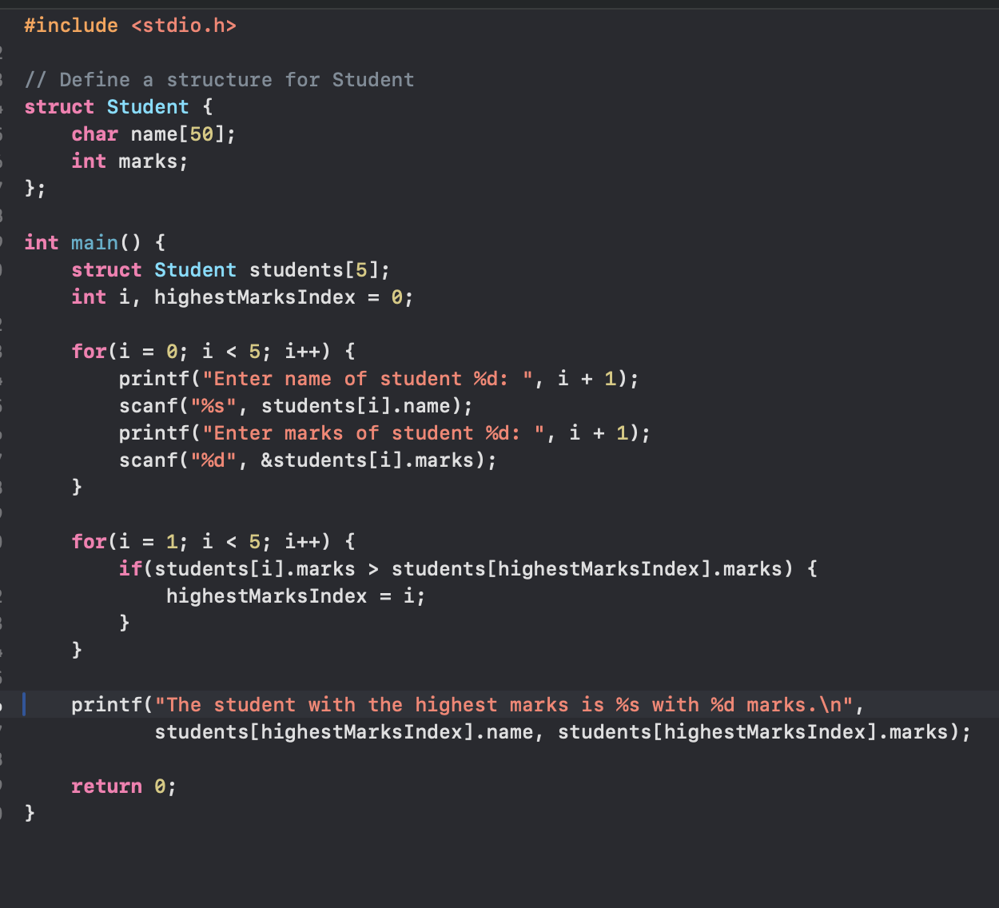

Create a structure to specify data of customers in a bank. The data to be stored is: Account number, Name, Balance in account. Assume maximum of 200 customers in the bank.

a) Write a function to print the Account number and name of each customer with balance below Rs. 100.

b) If a customer requests for withdrawal or deposit, the output should show the fields: Acct. no, amount.

c) Write a program to give a message, “The balance is insufficient for the specified withdrawal”, if on withdrawal the balance falls below Rs. 100.

